**AGAUS**

**Attire for Evening Events**

**8-11 June 2025**

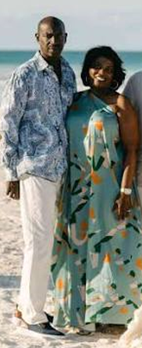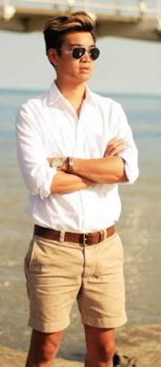**8 June 2025 – Welcome Reception – Theme: Coastal Casual**

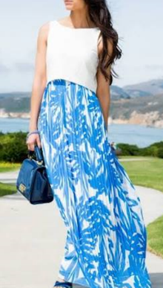

**9 June 2025 – River House Dinner – Theme: Casual- wear black, red, yellow, golds (sport coat optional)**



**10 June 2025 – Army Birthday – TAGs: OCPs Civilians: Casual (Green, Tan, Brown)**

**  
